Record year:
TONO's revenues in excess of 70 MEUR
“TONO's revenues have grown by 50 per cent in 5 years.”
(Oslo, 2 May 2019) "We are pleased to announce revenues of 71.1 MEUR, while our cost to income ratio of 11.3 per cent was the lowest in the history of the society", comments Cato Strøm, CEO of TONO, presenting TONO's accounts for 2018.
All amounts have been converted from NOK to EUR using the Exchange rate from 31.12.18. EUR 1 = NOK 9.95.
Growth is continuing for TONO, the Norwegian performing rights organisation, which celebrated its 90th anniversary in 2018. The market areas showing the most rapid growth are the digital area, the concert area and foreign revenues.
TONO’s gross turnover totalled 71.1 MEUR, a rise of 7 per cent from 2017. Net distributions aggregated 61.9 MEUR, up 9.1 per cent from 2017.
"We do not take this growth for granted. We are grateful to be able to manage an attractive repertoire, and 2018 was a demanding year in many ways. We are pleased not only with gross revenues of more than 70 MEUR, but also by the fact that we managed to keep our costs at 11.3 per cent, the lowest cost to income ratio in TONO's history", says Cato Strøm.
TONO's foreign revenues increased by just less than 16 per cent from 2017 to 2018, ending at MEUR 8. No fewer than 12 484 TONO members earned revenues from abroad in 2018.
TONO's foreign revenues increased by just less than 16 per cent from 2017 to 2018, ending at 7 MEUR. Other business areas also showed strong growth. The online area grew by 13.58 per cent to 15.1 MEUR, driven in particular by a rise in video-on-demand services such as Netflix, etc. Second is the concert area, where TONO’s revenues increased by 10.86 per cent from 2017, ending at 8.82 MEUR. The area generating the most income is broadcasting, as 19.59 MEUR of TONO's income was ascribable to radio and TV.
TONO made payments to 176 000 individuals in Norway and abroad in 2018.
TONO has experienced average growth of 4.7 MEUR per year over the past five years. During those same five years, TONO's total turnover has climbed by more than 50 per cent, from 47.18 MEUR in 2013 to 71.1 MEUR in 2018. Adjusted for inflation, TONO has had real growth of 45.17 MEUR since the year 2000.

TONO's financial statements and its annual report will be published on www.tono.no on about 9 May.
Figure 1: List of TONO's revenues in 2018
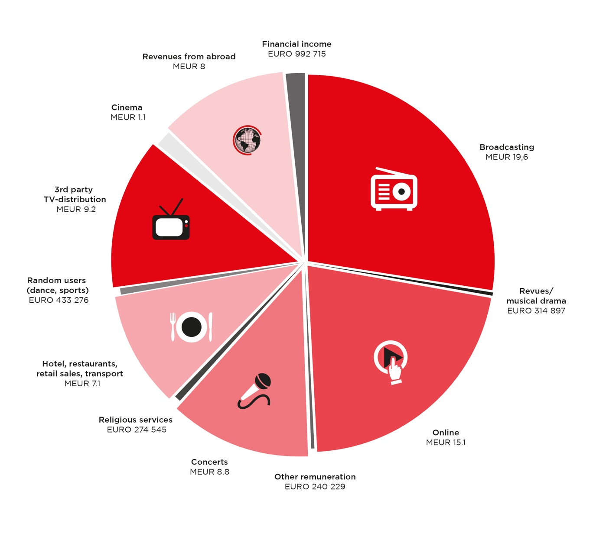

About TONO:
TONO is a non-profit cooperative founded in 1928, which is owned and operated by its members: Composers, songwriters, lyricists and music publishers. TONO manages performance rights for works of music in Norway and collects remuneration for public performances. TONO currently represents more than 32 000 Norwegian composers, lyricists and music publishers. Through reciprocal agreements with similar companies in other countries, TONO administrates the rights of more than 2.5 million creators on Norwegian territory. As a non-profit enterprise, TONO's profit is passed on to rightsholders to performed works. TONO paves the way for the use of music in society, at the same time as music creators are given a platform that allows them to continue creating new works of music. For more information, please visit www.tono.no.
For more information:
Cato Strøm, CEO
cato.strom@tono.no, mob. +47 922 16 319
Willy Martinsen, Director of Communications
willy.martinsen@tono.no, mob. +47 909 65 254

